INFORMATION TECHNOLOGY ACCESSIBILITY WORKSHOP

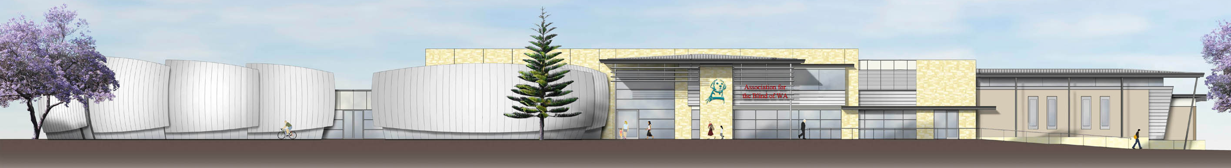
Association for the Blind of Western Australia

REGISTRATION FORM

Surname
First name
Name for name tag
Title
Organisation
Postal Address
State
Postcode
Telephone
Email
Special dietary requirements
Alternative format required

Workshop costs:
Registration includes morning/afternoon tea and lunch, and a Resource CD-ROM (GST inclusive).

Registration | Cost | My registration
Full registration Early Bird | $500
Full registration | $600
Group registration, 5 or more from an organisation. Number attending_______  Please complete duplicate forms for information on each attendee. | $400pp
TOTAL AMOUNT |  | $_____________

Please debit the total amount above to my credit card below:

Bankcard Mastercard Visa Other ___________________________________

Expiry date:

Signature_____________________________________________

OR Attached is my cheque for $________________

Please make cheques payable to Association for the Blind of Western Australia. Upon registration you will receive acknowledgment in writing and a tax invoice.

